Pos : 1
Kangaroos Winterjacket 10015468-black; 2 units
Size XXL

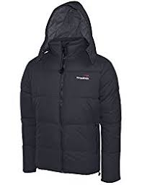

Pos : 2
Kangaroos Winterjacket 10015468-navy; 7 units
Size: 4xM, 3xL

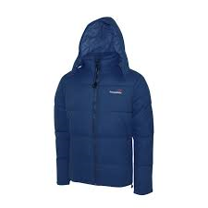

Pos : 3
Kangaroos Winterjacket 10015468-bluesky; 159 units
Size: 30xM, 60xL, 60xXL, 9xXXL

